**Praktikum 5**

**Pengolahan Citra Digital**

Nama : Muhammad Dzikri R

NIM : 1207070074

Kelas : TT 2023

Brightness -100

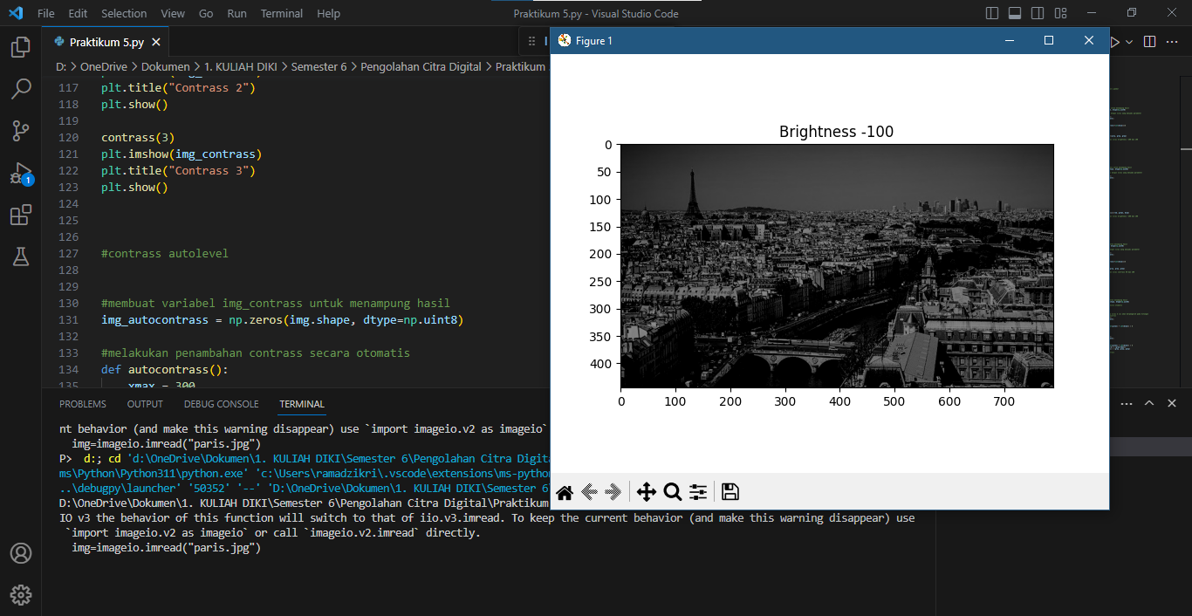

Brightness 100

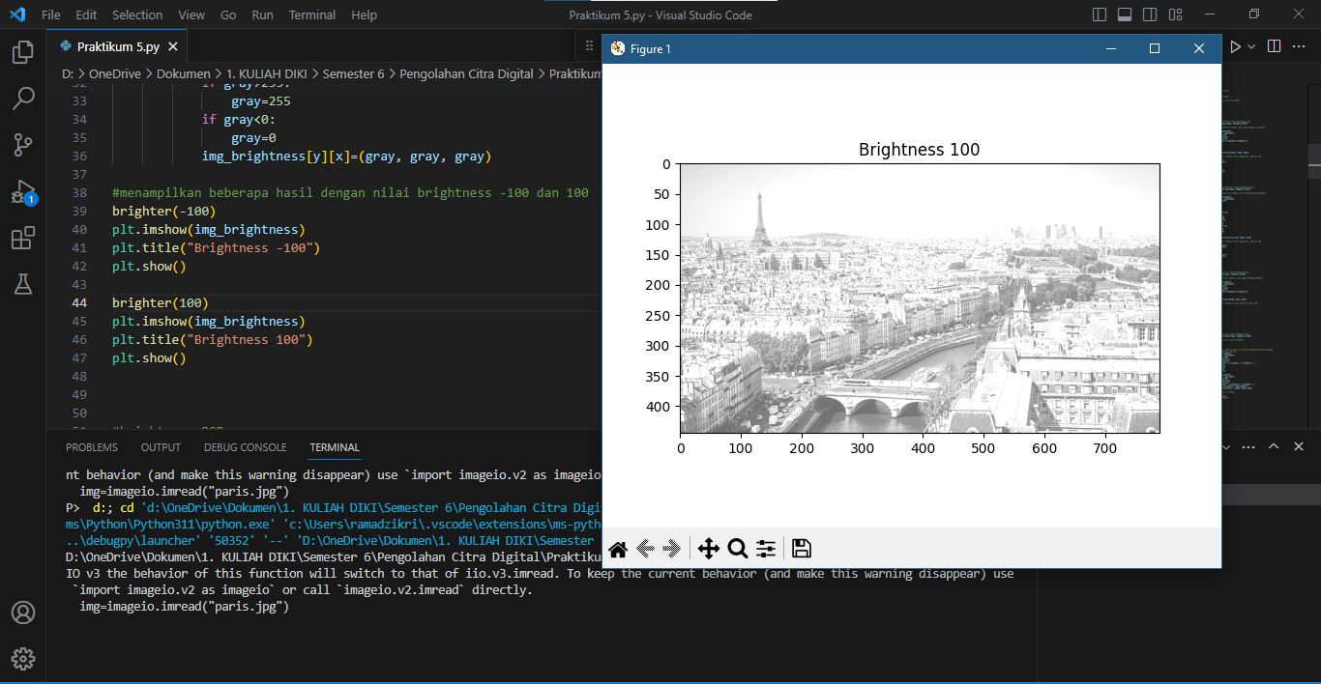

Brightness -100

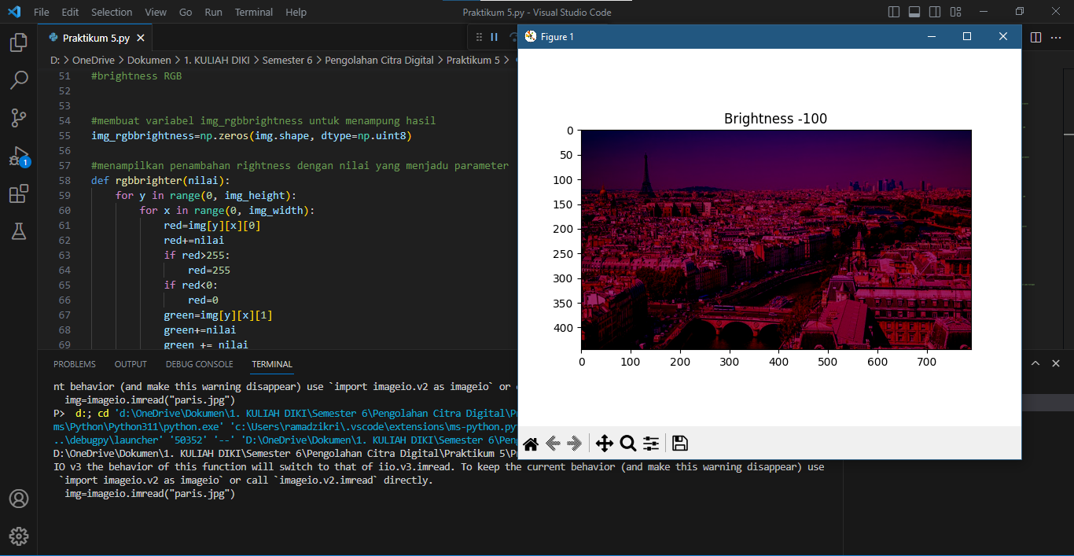

Brightness 100

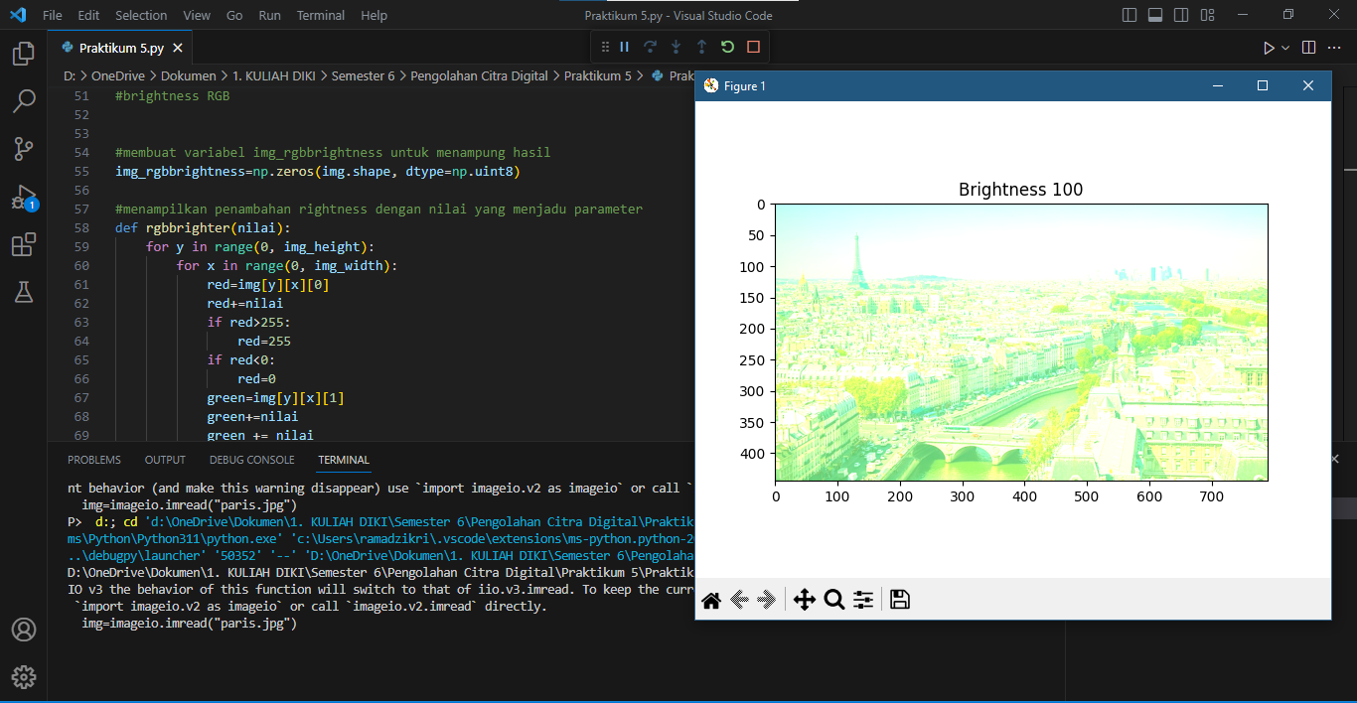

Contrass 2

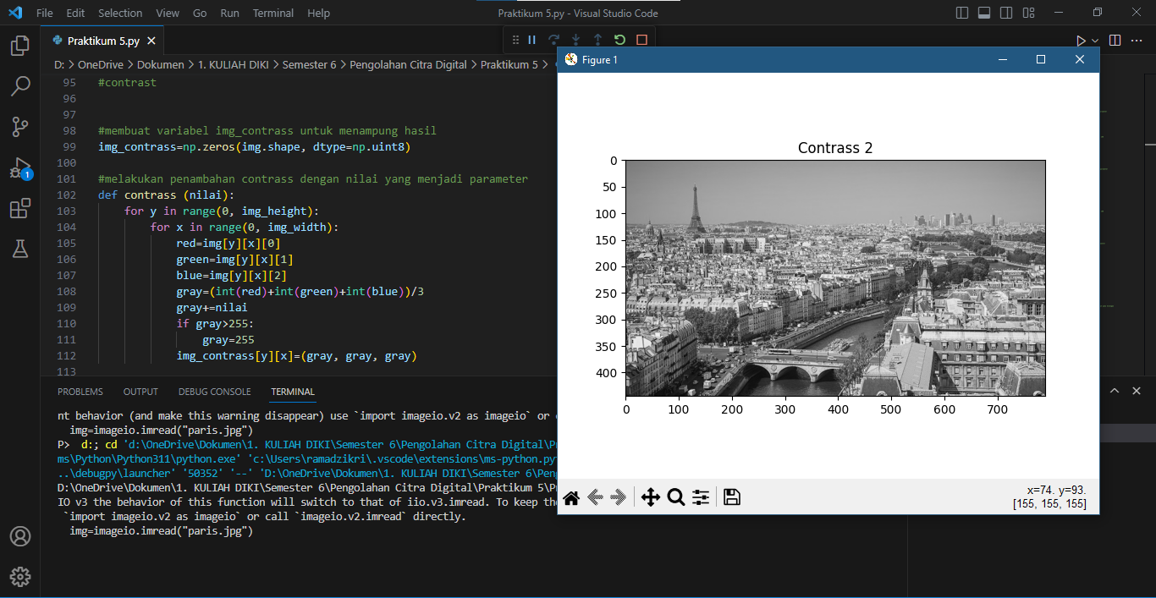

Contrass 3

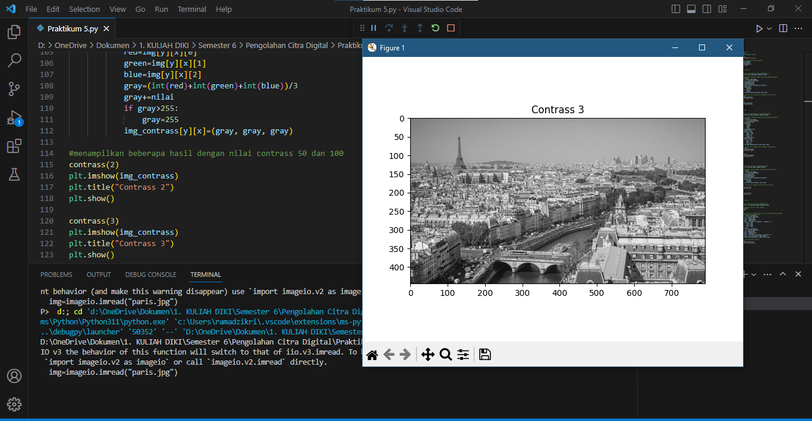

Contrass autolevel

